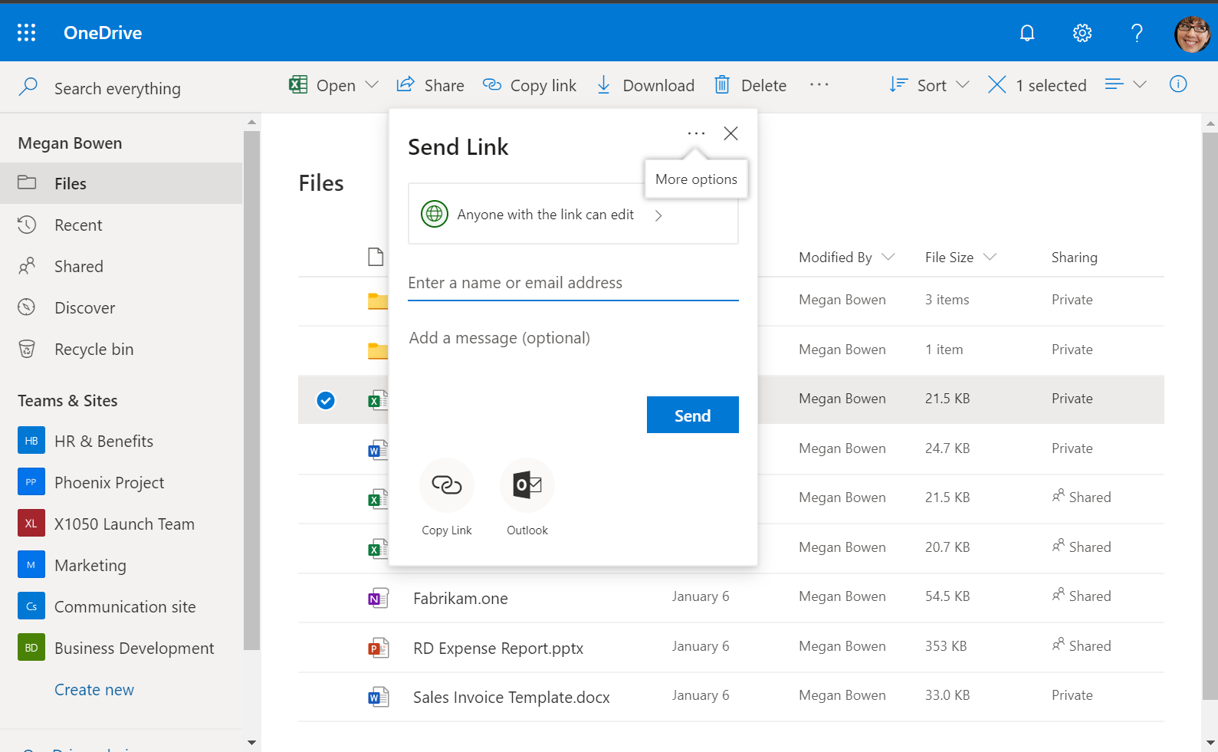

OneDrive is the new home for *your* files. It is available on any device: Windows, Mac, iOS and Android. It is the easiest way to securely store and share files online. This guide is intended to help get you familiar with the set up and use of OneDrive for Business.

Contents

Navigating to OneDrive on the web 2

Sync OneDrive to File Explorer 4

Activate the Backup feature 5

Moving files via File Explorer 6

Use the SharePoint Migration Tool to copy files to OneDrive in bulk 7

Working with sharing links 13

Access files on your mobile device 17

# Navigating to OneDrive on the web

Sign in to <https://portal.office.com> and navigate to **OneDrive**.

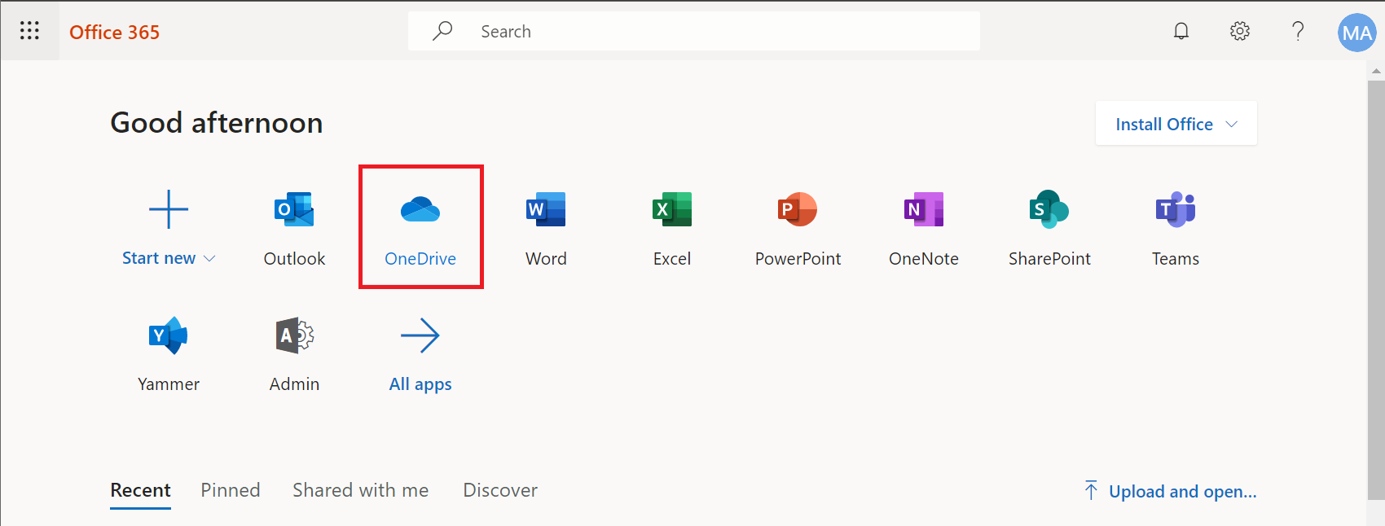

If this is your first visit, you may be prompted with a short introduction. Step through or skip.

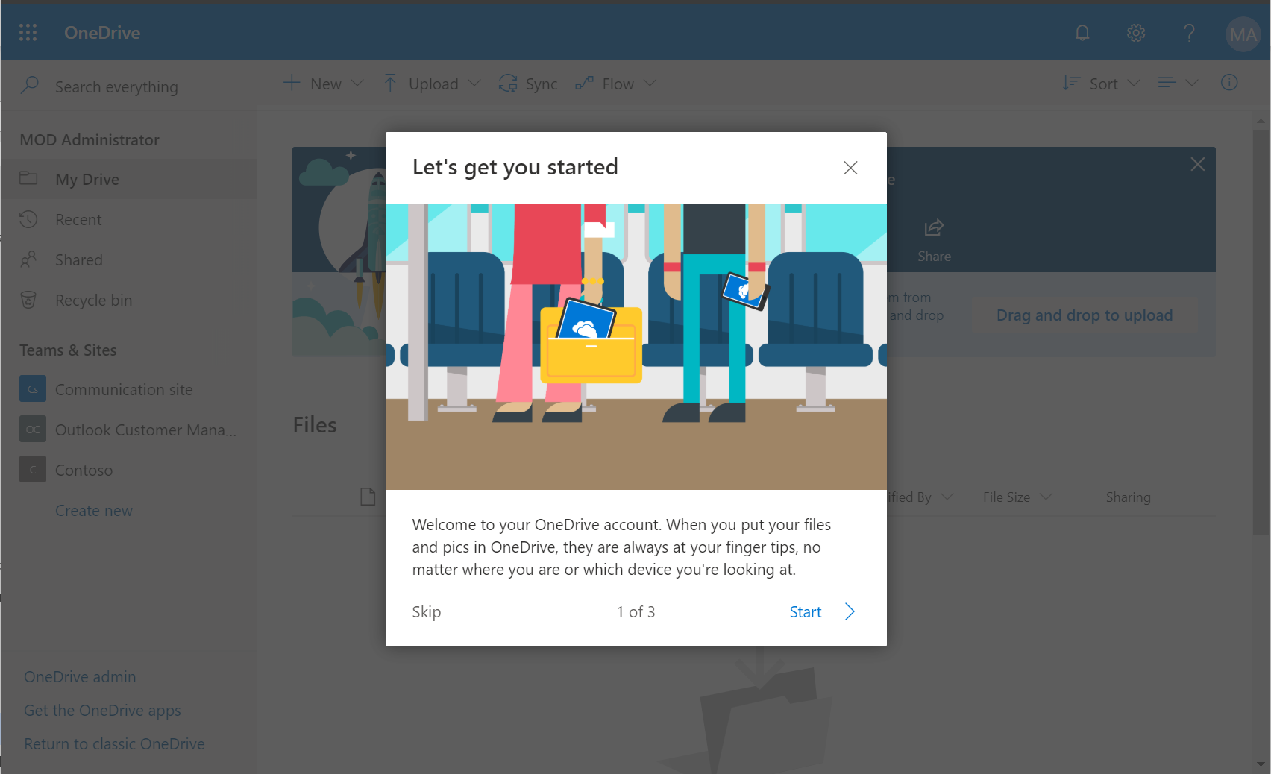

Now you can begin to create documents in the cloud or upload your own.

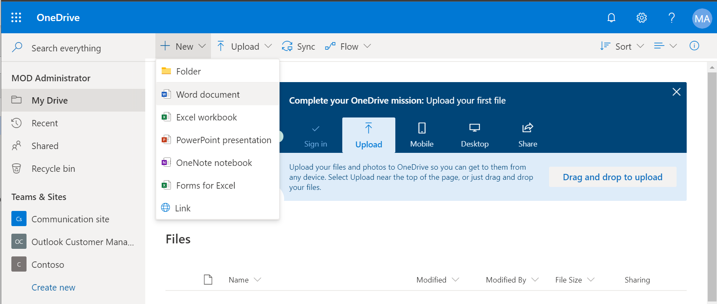

One easy way to get documents into the cloud is simply by dragging and dropping them right into the browser. This is not recommended for hundreds or thousands of files, but rather a few at a time.

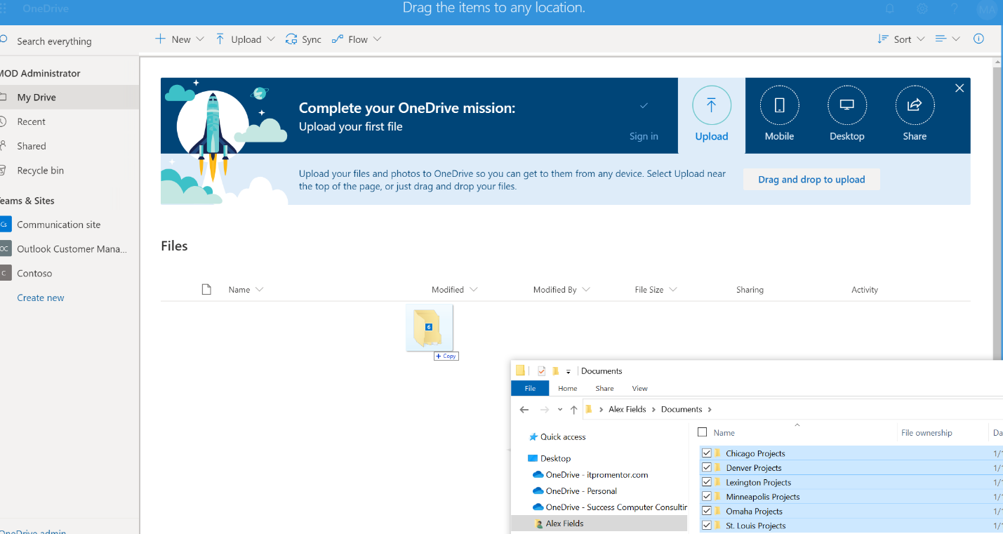

Drag-and-drop files from your File Explorer to copy small sets of files at a time (not recommended for bulk copies or migrations).

# Sync OneDrive to File Explorer

Do you have OneDrive for Business available in your Windows File Explorer? Check this out by opening **File Explorer** and looking for a **OneDrive icon** in the left navigation pane, it should have your **company’s name** listed behind it.

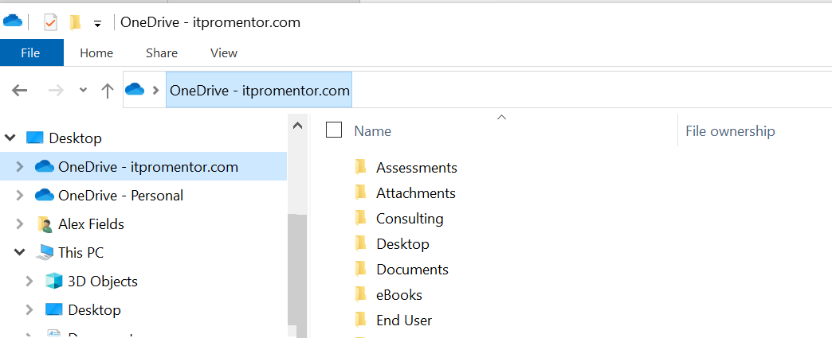

Corporate OneDrive files, managed by your IT department

Personal OneDrive files (unmanaged, and not visible to corporate IT)

If you do not see this yet, then your IT department has not yet set up OneDrive sync for your device, or the policy has not taken effect. That is okay; it is possible to accomplish this task yourself, also. From the web browser, simply click **Sync**.

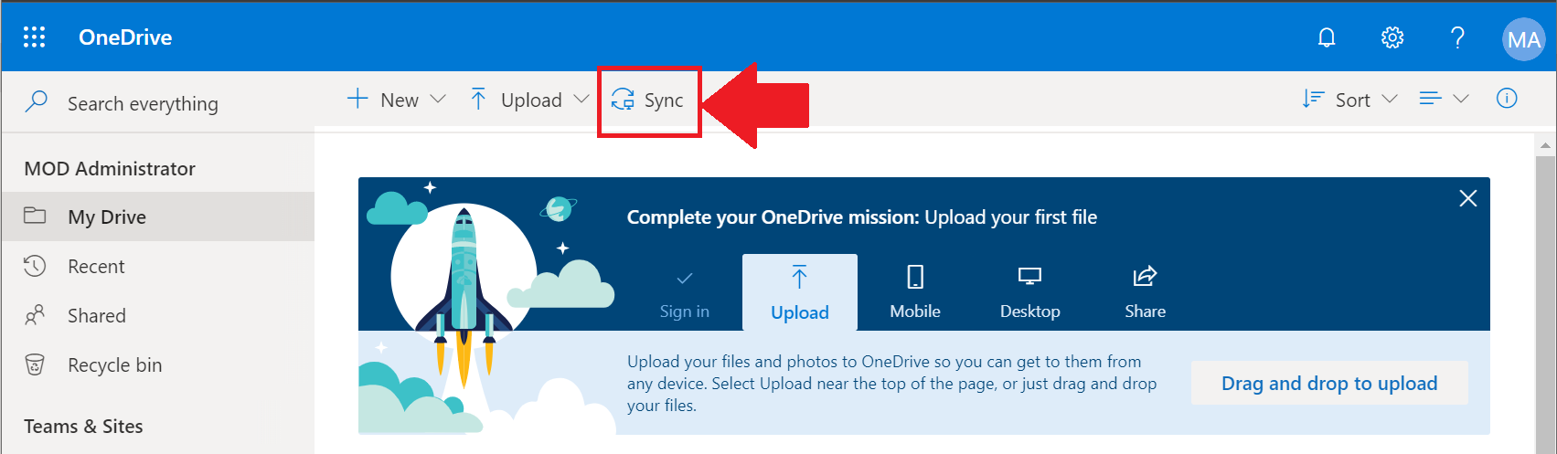

This will launch OneDrive and start syncing your files. Your corporate OneDrive location should be visible now in File Explorer.

# Activate the Backup feature

The backup feature will automatically sync any files in your Documents, Desktop and Pictures libraries on your local computer. This might already be enabled for you by your IT department, but otherwise you can turn it on yourself, too.

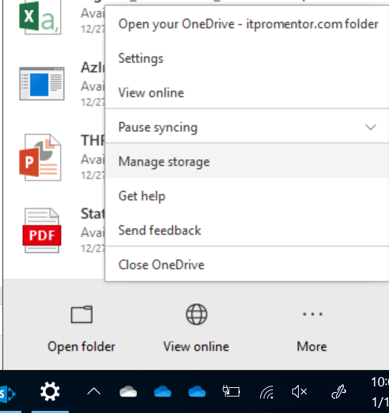

Click on the blue **OneDrive** icon in your taskbar, go to **More** and then **Settings**

Next go to the **Backup** tab and click **Manage backup**.

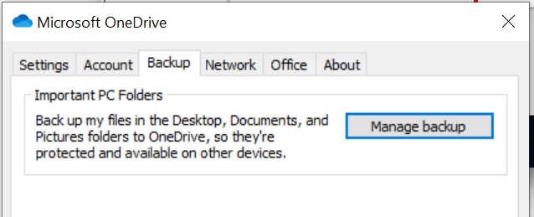

This should tell you whether your IT Department already manages this feature for you or just encourages you to use it, and whether the files are already backed up or not.

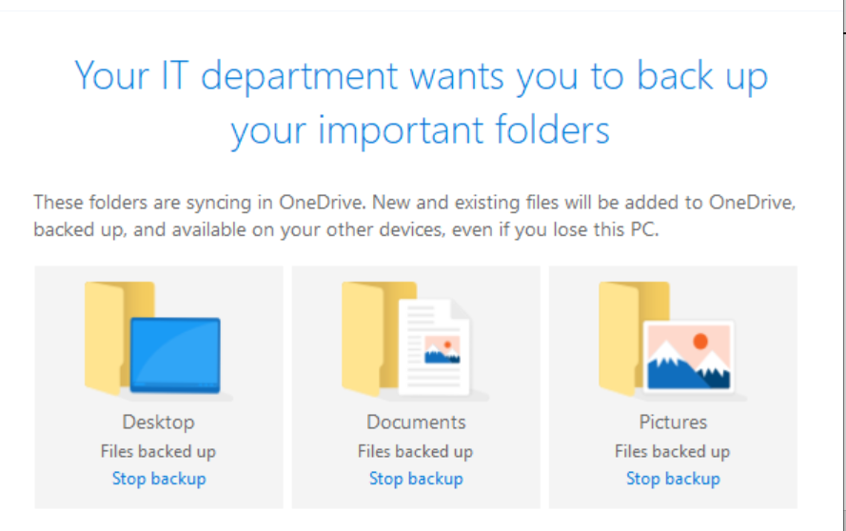

If not, you can also step through a simple wizard to finish the process.

Be mindful of these limitations, which could lead to sync issues:

* Invalid characters, e.g.: " * : < > ? / \ |
* File path including all subfolders should not exceed 260 characters
* Do not sync more than 300,000 items using the OneDrive sync client   
  (across all libraries)
* No more than 5,000 items per view or folder
* Review [the Microsoft support article](https://support.office.com/article/64883a5d-228e-48f5-b3d2-eb39e07630fa) for more details

# Moving files via File Explorer

Navigate to your files in **File Explorer**, select the files and folders that you want to move. **Right-click** the files and select **Cut** (you can also use **Ctrl-X** on your keyboard). Still in File Explorer, navigate to OneDrive where you want to deposit the files, and **right-click** to **Paste** (or **Ctrl-V** on your keyboard).

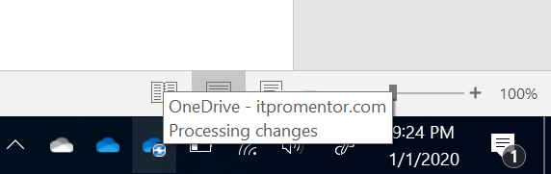

You can watch progress in the sync client in your task bar, down near the clock in the lower right corner of your screen.

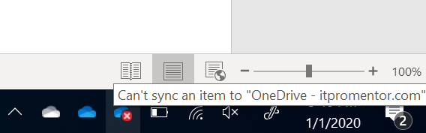

If there is an error with the sync, you will see it appear in the notification area. Clicking on the error will give you more details. File Explorer will also display a **red X** on the file(s) that could not be synced to the cloud.

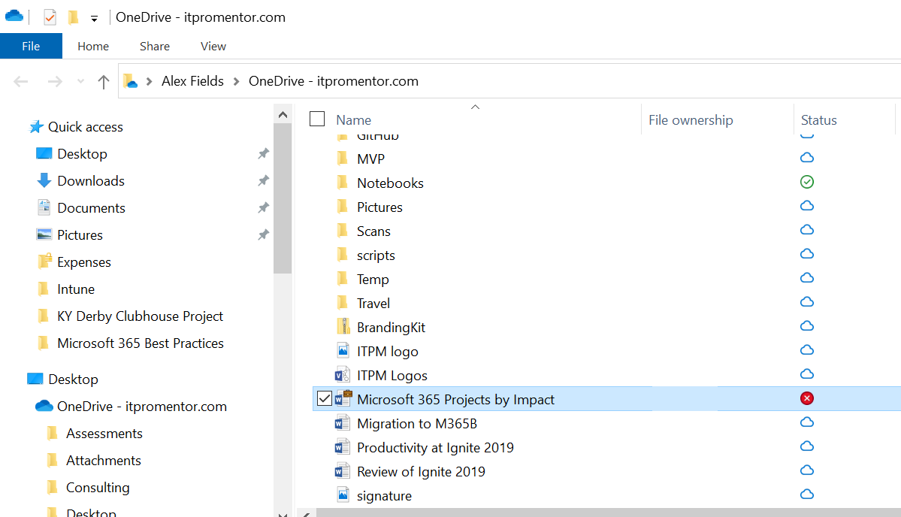

Also see [this article](https://support.office.com/en-us/article/fix-onedrive-for-business-sync-problems-207e983e-146d-404c-a994-672ef29e1f90) for tips on fixing OneDrive sync issues, should the need arise.

# Use the SharePoint Migration Tool to copy files to OneDrive in bulk

In the browser address bar, collect the URL for your OneDrive library: highlight and copy everything to the left of “/layouts/…” as pictured below:

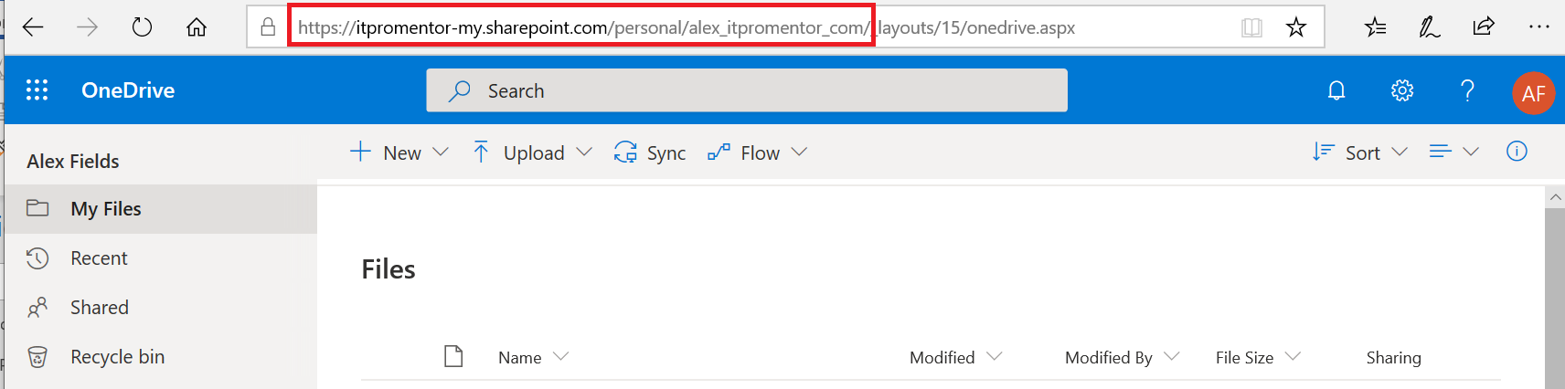

Next, download and install the [SharePoint Migration Tool](https://docs.microsoft.com/en-us/sharepointmigration/introducing-the-sharepoint-migration-tool#download-and-install) from Microsoft.

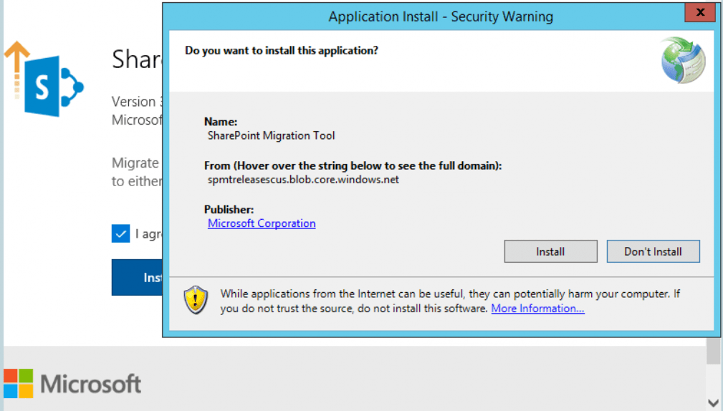

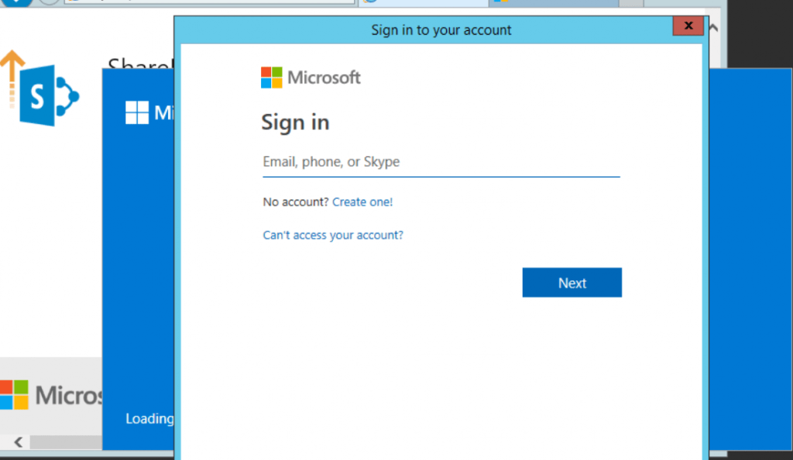

Once it is done installing, you will need to sign in to your Microsoft 365 account.

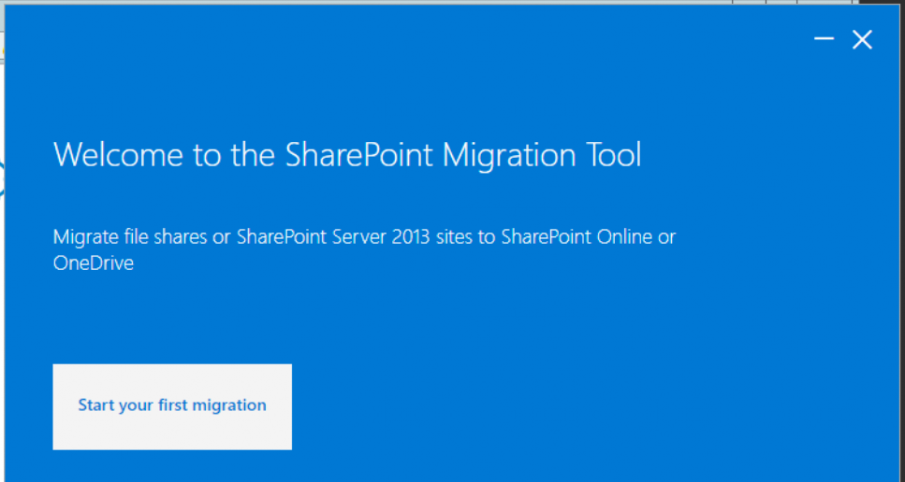

Click the big button to **Start your first migration**.

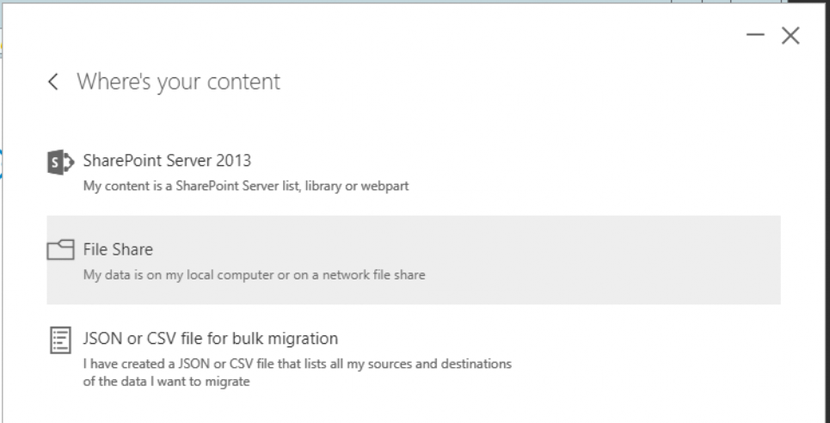

Pick the option for **File Share**.

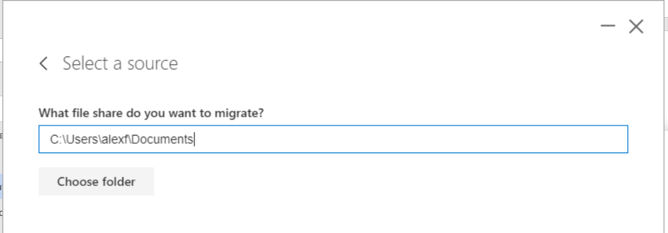

Specify the source folder—browse to the location of your personal files (not shared or team-based files) with the **Choose folder** option, and then click **Next**.

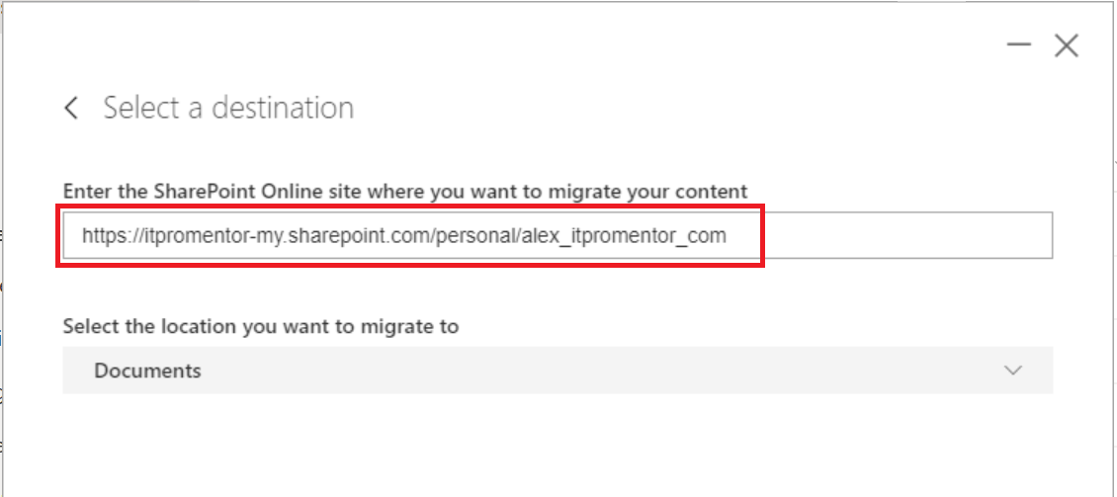

Specify the destination—this is where you **paste the URL path** to your OneDrive library. You can also select the destination in the dropdown below—Documents is the root level folder of your OneDrive library.

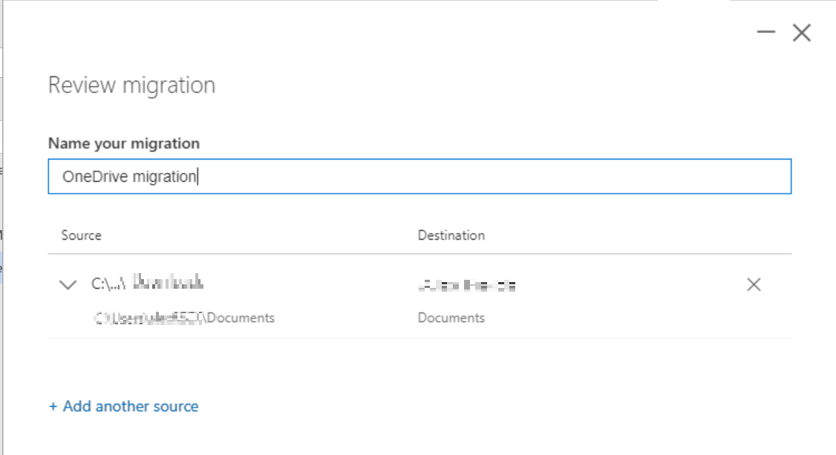

Name the migration and optionally add more sources from which to copy data.

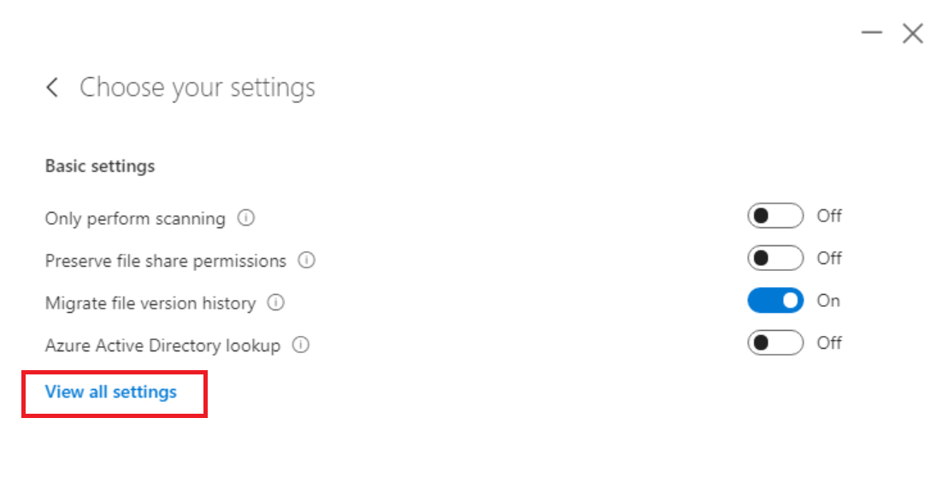

Click **View all settings** to see more options: consider filtering based on last modified date.

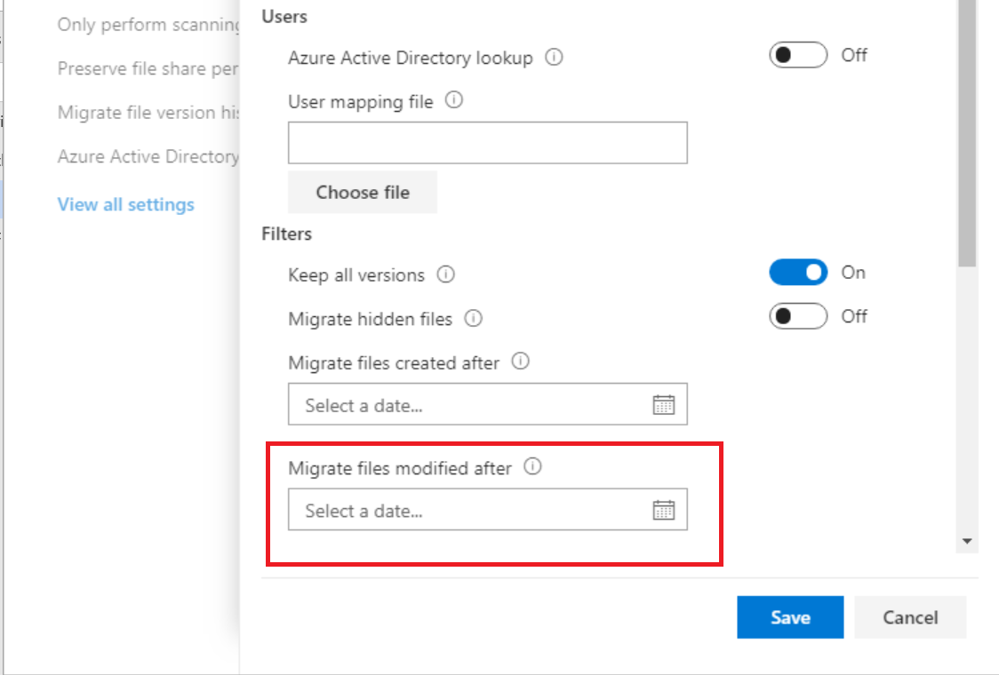

**Save** your selections and then click **Migrate**.

# Working with sharing links

Sharing links are the easiest way to securely share files in the cloud. Generating links looks identical in almost every interface, whether you use it on the web, or in File Explorer, and in other applications such as Outlook or even mobile apps. **Right-click** on a OneDrive file in File Explorer, and you will find an option to **Share**.

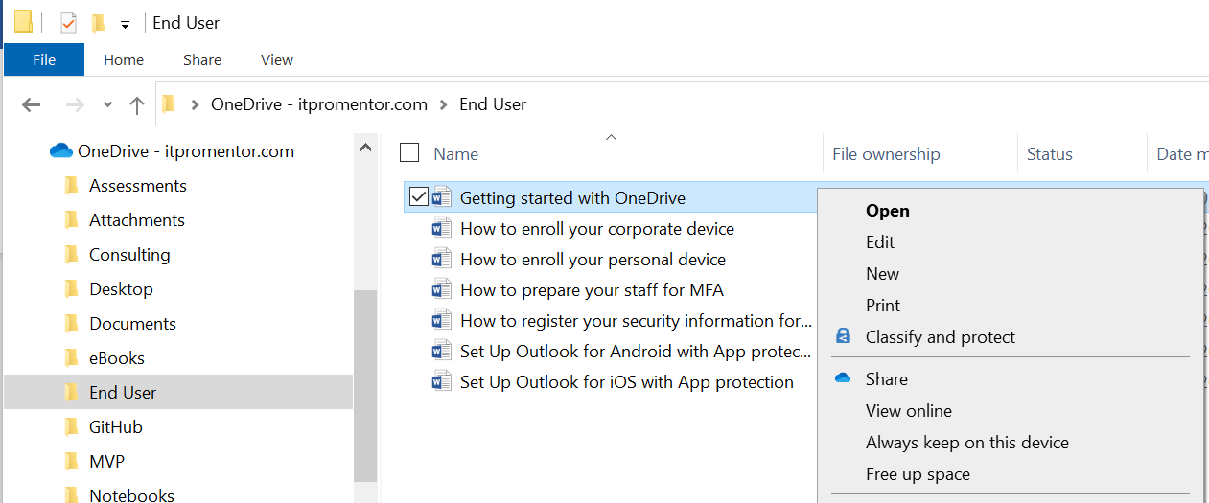

On the web, it looks very similar: click a file, and click **Share**.

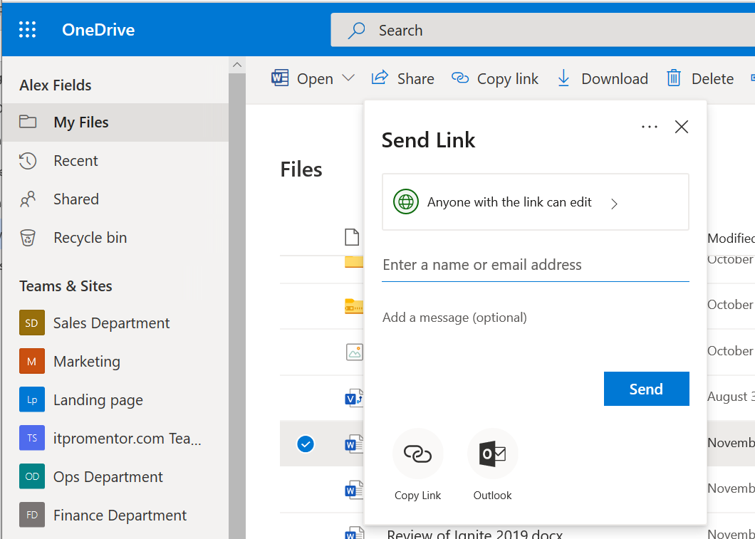

Before proceeding, click to expand the permissions choices that you have.

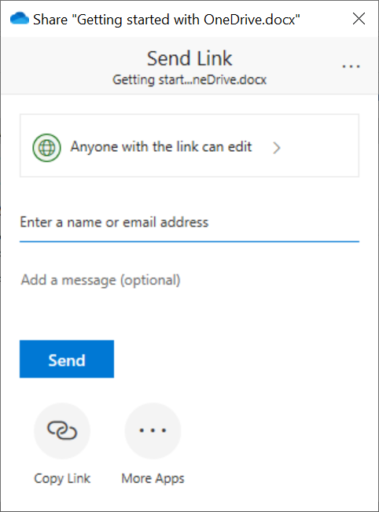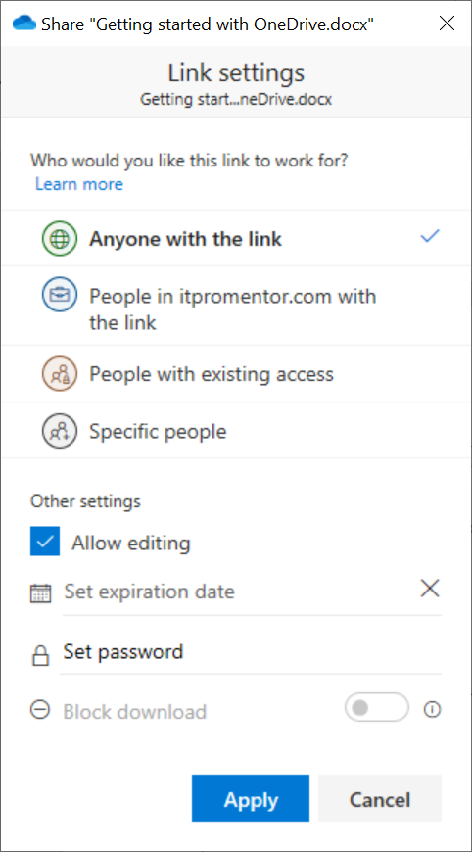

There are four types* of links you can choose between.

* **Anyone with the link** – This is a secret, revocable link that is transferrable to other people. That means it **behaves exactly like a normal attachment**. If you send it to someone, they can forward it to anyone else. This is my go-to: it is the **easiest** type of link to use, as it does not require any sign in—just click the link to see the file.
* **People in [Your Organization] with the link** – This is a secret, revocable link that is transferrable only within your company. If someone in your organization attempted to forward this link to an outside party, they would not be able to access the file.
* **People with existing access** – If you have previously granted access to certain individuals, and you just need to get a link to send again, then you can use this option.
* **Specific people** – This is a secret, revocable link that is non-transferable. Only people you specify can open it. These people will be required to prove their identity with a one-time code sent via email.

Notice that you can also toggle **Allow editing**, **Set an expiration date**, **Set a password**, or even **Block download**. Using links, you can confidently share files, granting only the level of access you want and for the time you want it.



OR **Copy Link** then paste anywhere

This option is used to send an email to specific recipients

After making your selections, you can enter an email address and add a message (optional) then press **Send**. The below is an example of what the recipient would see.

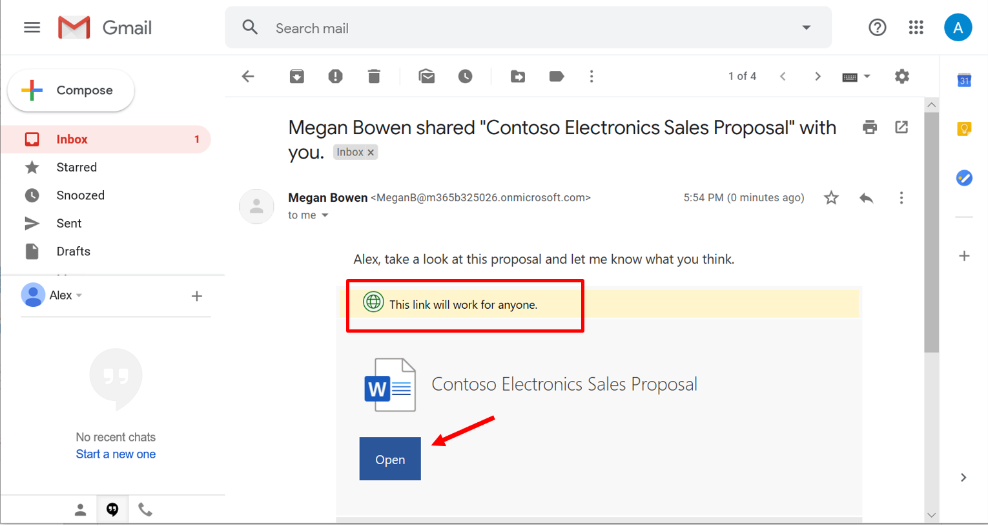

This is an example of the **Send** option

Otherwise, if you **Copy Link**, then you can paste your link anywhere you like, whether Outlook, Teams, or even social media (e.g. Anonymous links would work anywhere).

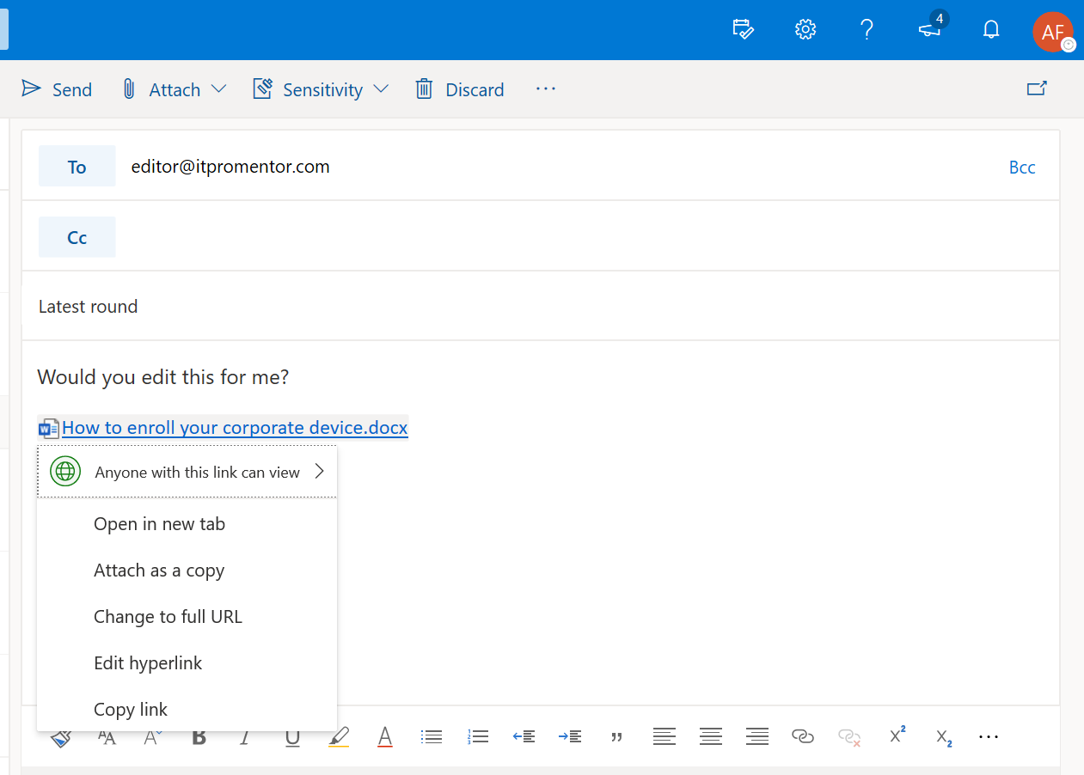

Adjust permissions on the fly without returning to OneDrive

Click the link that you pasted into your email body

In the Outlook web client, you can click on any link that you pasted to adjust its permissions without returning to OneDrive. This integration will begin to work for more Microsoft 365 applications during the course of 2020.

Links are ***better*** than email attachments, since you can **customize permissions** (e.g. do not allow editing, block download, etc.), and you can also **rescind access** at any point in time, or automatically expire access after a specified period of time has elapsed. Not only that, but any changes or edits made by recipients of your file are saved back to your OneDrive automatically, without having to send multiple attachments back-and-forth.

*Note: If you do not have the option to use Anyone links, bother your IT department and explain to them how important it is that you have an easy, frictionless option for sharing content externally when you see fit. Threaten to move to your own DropBox account if they don’t turn this back on for you.

# Access files on your mobile device

Now that your files are in the cloud you can access them from anywhere, even mobile devices. Be sure to go download the OneDrive app for iOS or Android from your favorite app store.

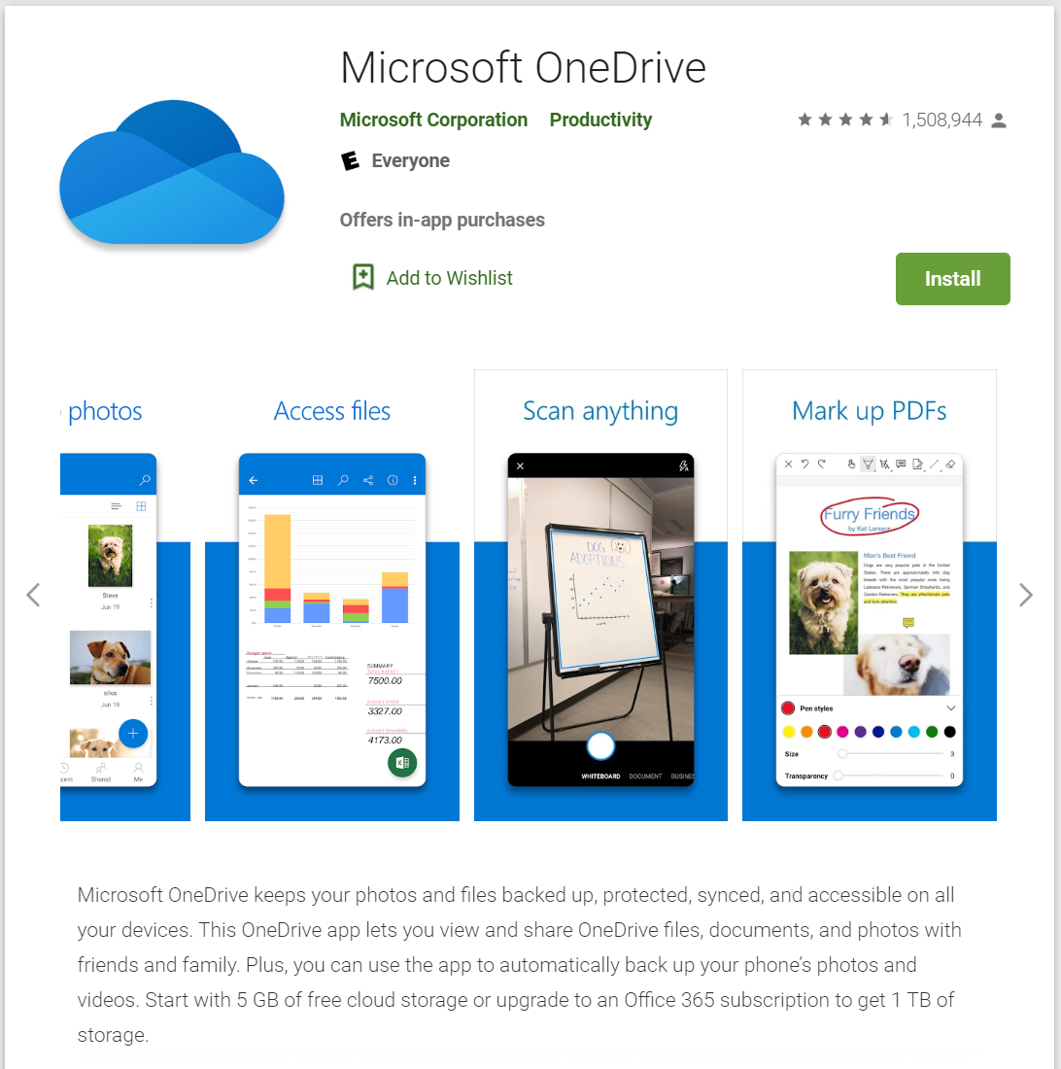

Within the app, you can access all of your files in Microsoft 365. You can also *scan* files into OneDrive using your mobile device’s camera, and the text becomes searchable!

In fact, all of the major Office applications are available on mobile platforms. Get started today.